Rolla to Pilot Knob Area Field Exercise Guide

GeoE 50 - Geology for Engineers
J. David Rogers
Missouri University of Science & Technology

Observation Site No. 1 - (Getting onto I-44, eastbound)

The site for the Lowes Hardware facility between north Hwy 63 and I-44 was created by removing “junk” fill from the southern footprint of the retail building area and constructing the building and parking lot pads on compacted fill borrowed from the western and northern portion of the site. Because of the barrow activities, some over-steepened slopes were created along the north and west sides, which subsequently experienced erosion problems. These have been stabilized by regarding, hydroseeding, and construction of drainage improvements. Notice these methods and their respective effectiveness. Also, the surface drainage way to the south and east of the main building has a series of erosion control/stabilization measures applied to its course. Notice these and their effectiveness.

Observation Site No. 2 - (4.2 miles south of Cuba Exit from I-44)

The course of our route along Interstate 44 from Rolla to Cuba, Missouri (founded in 1857) alternates between driving on a landscape developed on carbonate rock terrain and one developed on the undivided sandstones and shales, which overlie the older carbonate rocks of the Cotter and Jefferson City formations. The amount of relief seen along this course of travel may be directly related to the underlying bed rock units, i.e., the less resistant clastic rock units tend to weather and erode more-or-less uniformly; whereas the carbonate unit tends to weather preferentially along fractures facilitating the differential down cutting compared with the isolation of highs. Note carefully the change in the landscape as we leave Cuba, driving south along Hwy 19 (big drop in elevation).

Observation Site No. 3 - (7.4 miles south of Cuba Exit from I-44)
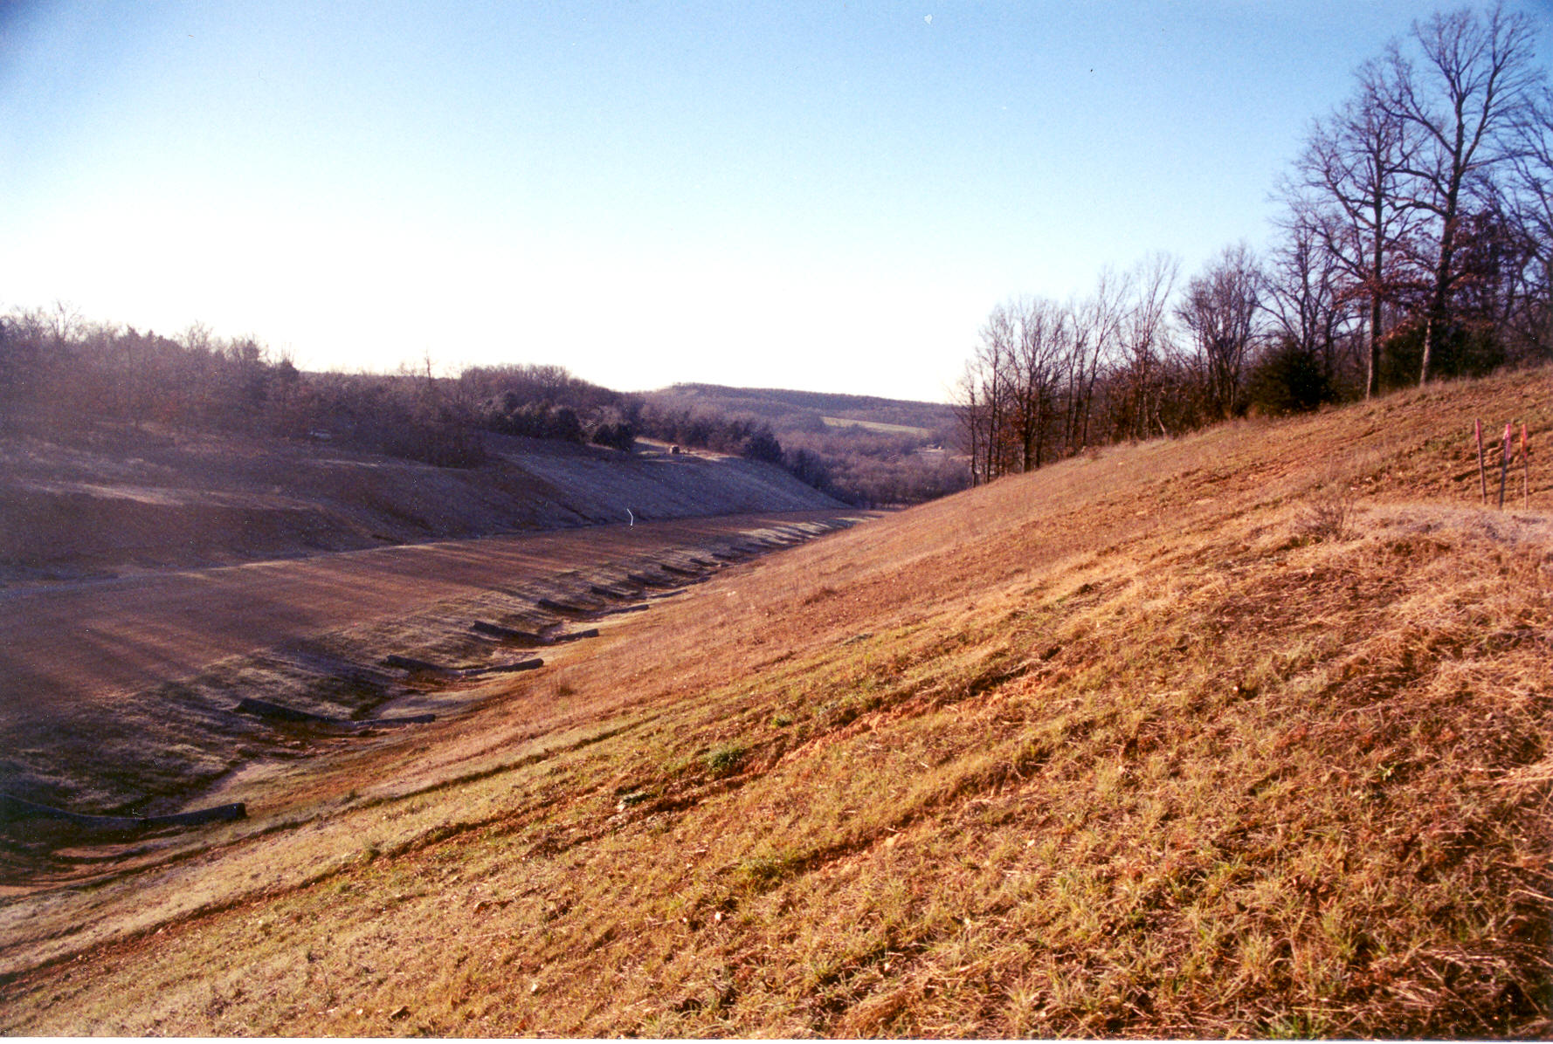
Figure 1. Missouri 19 Road Cut in Roubidoux Formation, as viewed in 2001.
The Missouri Department of Transportation (MO DoT) elected to replace an accident prone crossing of Mo Hwy 19 over the Meramec River and eliminate a number of blind curves by re-grading a few miles of the highway. Most of this project is situated in terrain underlain by carbonate and sandstone/shale bedrock, largely in the Roubidoux Formation. This major realignment was carried out in 2001-02 and required deep cuts and fills. Figure 1 shows this cut as it was being developed. Notice the limited exposures of the bedrock in this area. The slope was laid back t 2:1 (horizontal to vertical) to promote stable slope conditions. Note the soil/bedrock interface conditions where this zone is exposed.

Observation Site No. 4 – Meramec River (9.7 miles south of Cuba Exit on I-44)

The new alignment of Hwy 19 takes us over the Meramec River and its adjacent flood plain. Note the light colored piles of sand and silt deposited by recent flooding in 2008. Note the contrasting geology exposed in high way cuts as the highway climbs southward, out of the river valley. We are passing through a highly weathered and dissected carbonate upland. Notice the erosion control measures employed my MoDOT to the long back slopes of the deep cuts in the uplands south of the Meramec River, comprised of Gasconade Dolomite (which underlie the Roubidoux Formation, see stratigraphic column at end of this guide). Make a note of those locations where active erosion has occurred along the cuts and fills north and south of the river valley. Highway 19 joins State Hwy 8 in Steelville, which dates back to the founding of a gristmill in 1833. The town is named after James Steele, who arrived in 1835. Iron ore was mined from ancient sinkholes in Cherry Valley, a few miles southeast of town. Stay on Hwy 8, eastbound for Potosi.

Observation Site No. 5 – Huzzah Creek (9.2 miles east of Steelville)

The course of our travels will now take us east from Steelville toward Potosi along Missouri Hwy 8. We will cross a few Ozark streams, some of which have well-developed flood plains and others that exhibit a more typical stream-cut valley cross-section. Huzzah Creek is named after the Osage Indians, who pronounced their own name as “Wa-sha-zhe,” which white sttlers turned into Hoozaw, Huzzah, or Wousau. The French came up with Osage to describe the tribe name. Huzzah Creek has a well-developed flood plain. This watershed was completely denuded in the late 1800s as great swarms of timber were harvested for railroad ties in this basin and floated down Huzzah Creek. Today, the Huzzah is one of Missouri’s recreational rivers, used for float trips. Notice the morphology of the flood plain and recent evidence of high water. The bank lines near the Hwy 8 bridge have been altered by the recreational use of the stream. However, in the distance beyond either side of the highway crossing, the natural bank conditions are readily observable.

Observation Site No. 6 – Courtois Creek (17.4 miles east of Steelville)

Hwy 8 crosses Courtois Creek, which is pronounced “Code-a-way.” The divide we have crossed between the Huzzah and Courtois watersheds was followed by General Ewing and his retreating forces in their forced march of 67 miles between Pilot Knob and Leasburg in September 1864. As we proceed easterly towards Potosi note the mix of trees, cedars love to attach themselves to limestone and dolomite. Pine trees tend to favor acidic soils, such as those developed on sandstone and chert.

Bathroom Break at McDonalds in Potosi

Proceed 36.7 miles east on Hwy 8 to Potosi, MO. Rest Stop at McDonalds, on left. ¼ mile before intersection with State Hwy 21. Potosi is named after San Luis Potosi, a famed mining town in Boliva. Lead ore was discovered here around 1773 by Francois Azor of Breton, France. Shortly thereafter, French miners founded the town that came to be known as Old Mines, six miles to the north. This is also the hometown of Stephen F. Austin, who moved to Texas in 1820 and became the first President of the Republic of Texas in 1835 (his father Moses Austin is buried here). Potosi was once the state’s largest producer of barite (tiff), extracted from barium sulphate. Barite is heavy and used in drilling muds for oil wells. The barite was also used for pigmentation of white paint and as a radiation shield (barite absorbs free neutrons and x-rays). Barium sulphate is still used as a x-ray marker for digestive exams.

Observation Site No. 7 – Big River fault (8.9 miles south of junction of Hwys 8 and 21 in Potosi)

The highway crosses the Big River and the Big River fault. Note the contrast in topography and vegetation as we proceed south. The fault has lifted strata about 1000 feet relative to the surface we have been traveling on. Erosion has exposed strata of the Cambrian age Bonterre Dolomite and Davis Shale, which support less rugged topography and much richer agricultural soils than other ports of the Ozarks.

Stop Number 1 - (9.3 miles south of junction Hwys 8 and 21 in Potosi). Cross the highway only after our traffic warning cones have been set and the two traffic control functionaries are in place to protect us from passing traffic. Very carefully work the face of this outcrop and cross back to the bus ONLY AFTER HAVING CAREFULLY CHECKED FOR APPROACHING TRAFFIC FROM BOTH NORTH AND SOUTH.

Just south of the Big River crossing along Missouri 21 our travels take us to an exposure of some interbedded carbonate and shale, namely the Davis Formation. The Davis Formation is known as an aquitard. This upper Cambrian unit forms the “roof rock” for the deep lead-zinc mines in the Viburnum Trend west of our location and some 400 to 1,300 feet below ground. Figure 2 shows an overall view of this exposure, while Figure 3 presents details of the small fault exposed at the north end of the outcrop. This stop provides an excellent example of the differential weathering of shale vs. carbonate in a vertical exposure. The fault gouge is easily observed. Note the crosscutting nature of the fault relative to the bedding. The shale would be expected to form barrier to the downward percolation of water through the fractured carbonate, while the fault would limit lateral percolation. There is an unusual “edgewise conglomerate,” exposed near base of this outcrop Listen for possible explanations. What does cryptoexplosive origin connote? Submarine landslide?
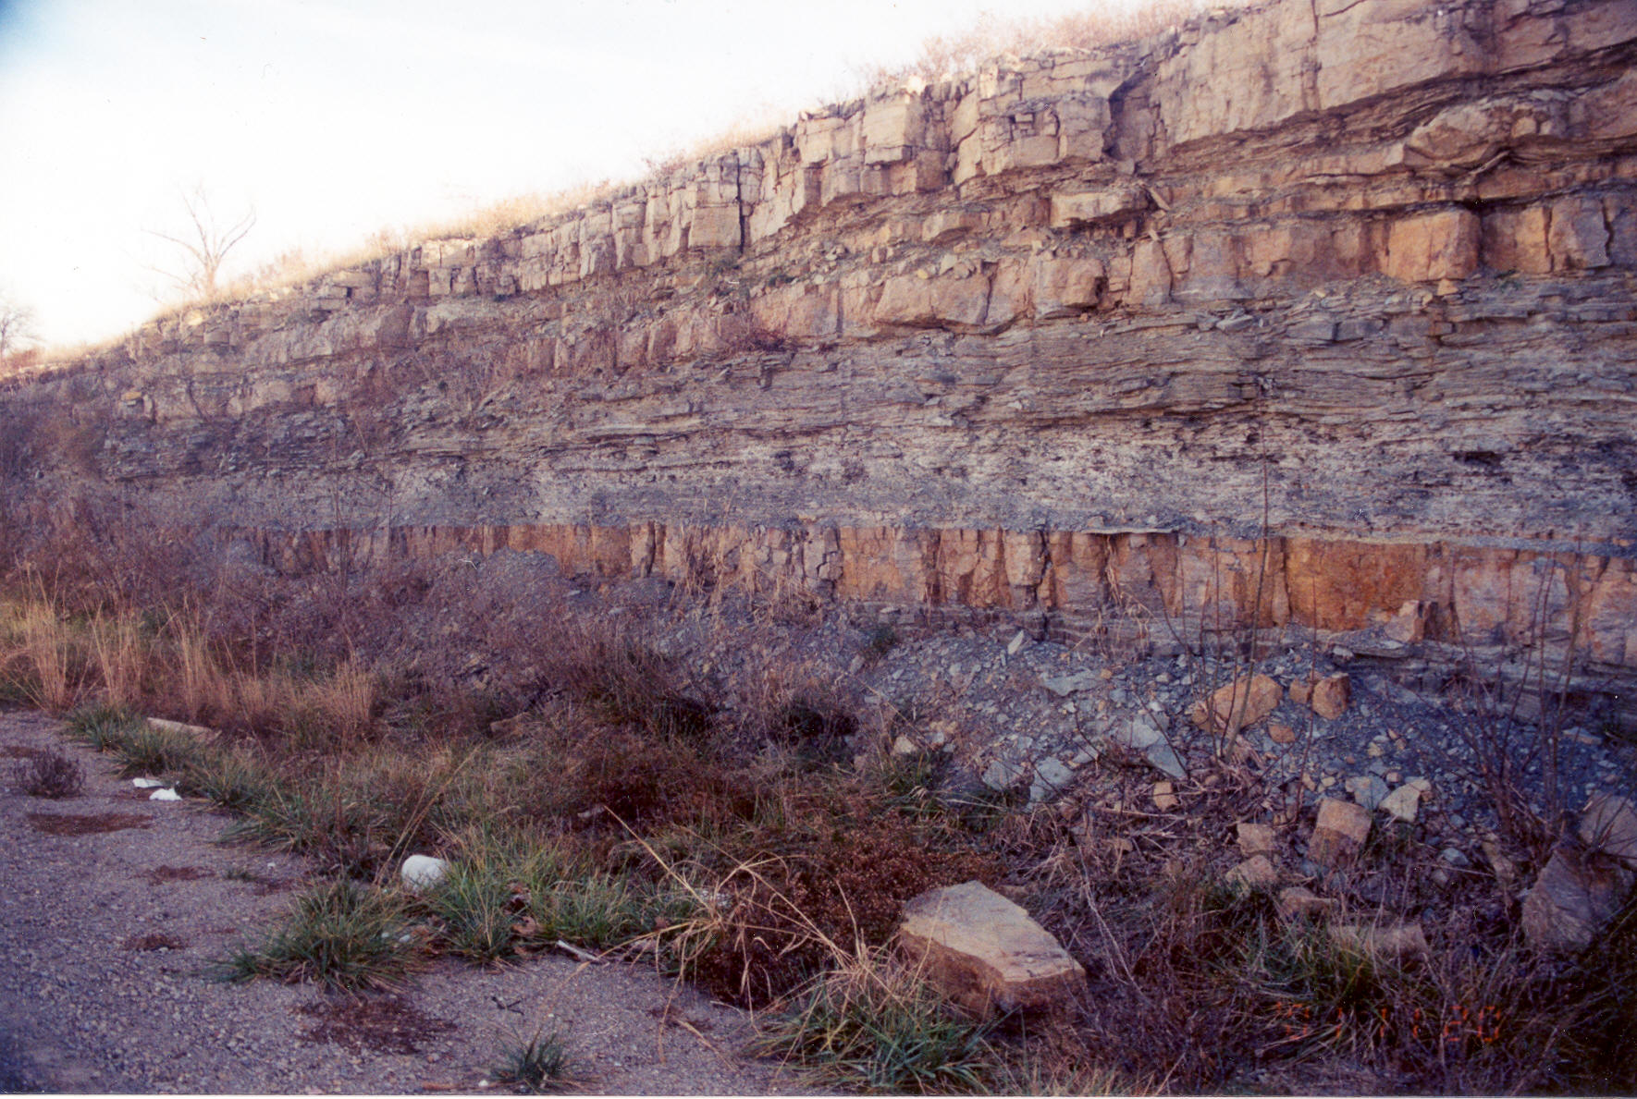
Figure 2. Overview of the Carbonate/Shale Outcrop. Note algal mound at upper right.

Observation Site No. 8 – Caledonia (12.4 miles south of junction of Hwys 8 and 21 in Potosi)

We are passing through the scenic village of Caledonia. It was settled by Scotts and Scott Irish settlers, beginning around 1807. The brick houses on the right side of the highway (#205 and #307) both date from around 1832. A number of Civil War graves in the village cemetery bear testimony to the intense fighting that initiated here between Union and Confederate troops in 1864, as the Yankees found themselves trapped between Rebel units on their front and rear, as they were attempting to retreat from Fort Davidson to the Frisco Railroad line. The Yankee soldiers adroitly employed their six mobile canons as they fought a series of rear-guard actions against pursuing Confederate cavalry, which culminated with a skirmish near Leasburg.

Stop Number 2 - (14 miles south of junction Hwys 8 and 19 in Potosi). Cross the highway only after our traffic warning cones have been set and the two traffic control functionaries are in place to protect us from passing traffic. Very carefully work the face of this outcrop and cross back to the bus ONLY AFTER HAVING CAREFULLY CHECKED FOR APPROACHING TRAFFIC FROM BOTH NORTH AND SOUTH.

This stop is just north of the crossing of Missouri 21 and Cedar Creek, about 1.3 miles south of Caledonia. This exposure includes the Lamotte Sandstone, the basal unit of the Paleozoic sequence, which laps onto the Precambrian volcanic tuff and rhyolite; in order of exposure, from the north part of the outcrop to the south. Figure 4 shows the basal sandstone resting on the tuff. Figure 5 shows the rhyolite exposed in the outcrop along the east side of the highway. Notice the character of the three rock types exposed at this outcrop. The composition of the basal sandstone may be compared with the composition of the tuff. Observe the patterns and spacing of the joints in the various rock units that are exposed in this outcrop.
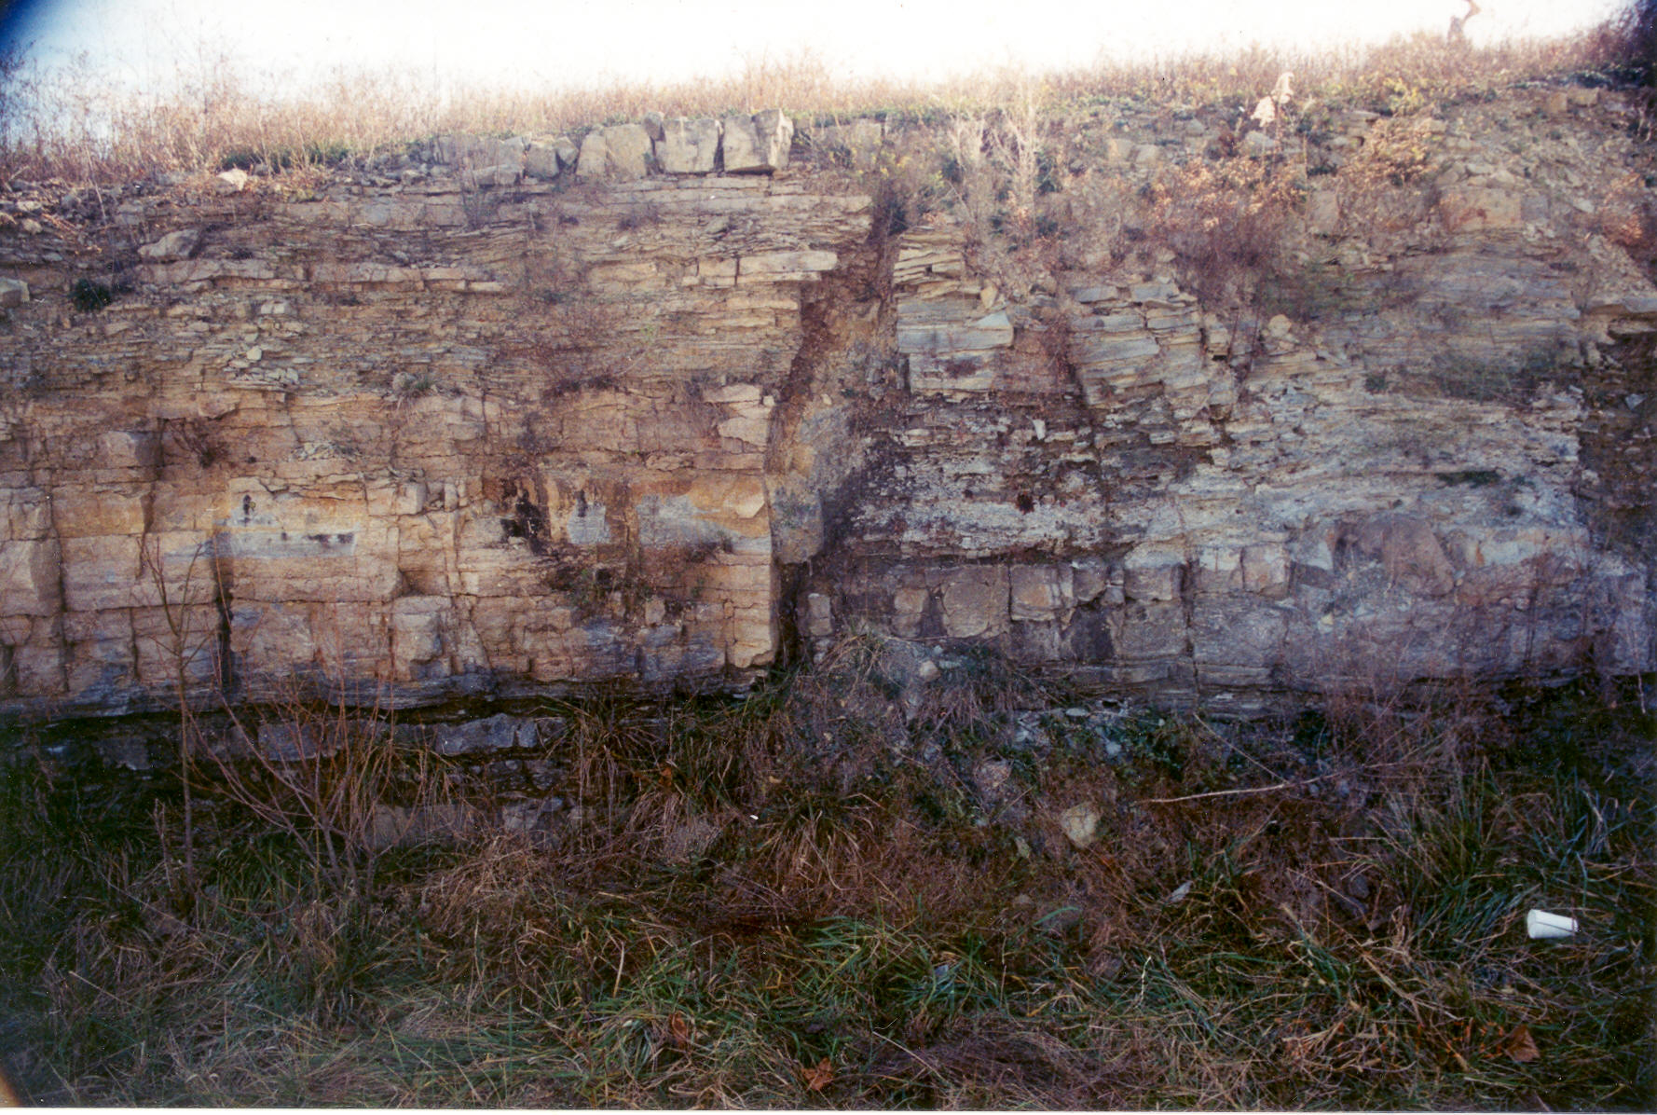
Figure 3. Close up of the Small Fault, North End of the Carbonate/Shale Outcrop
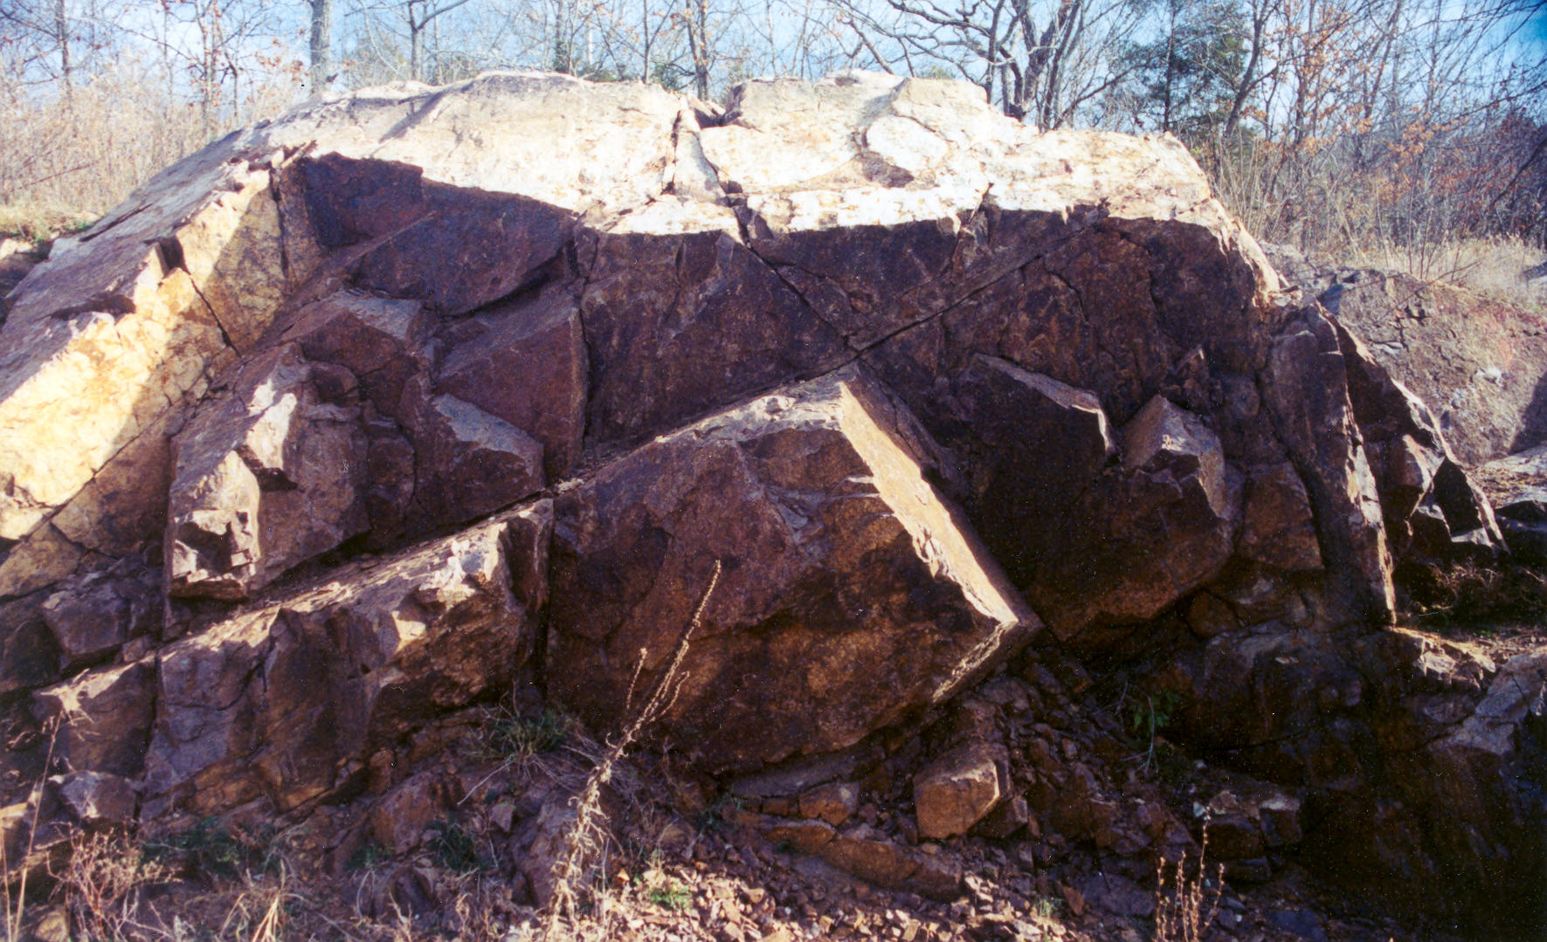
Figure 5. Outcrop of blocky rhyolite, showing jointing
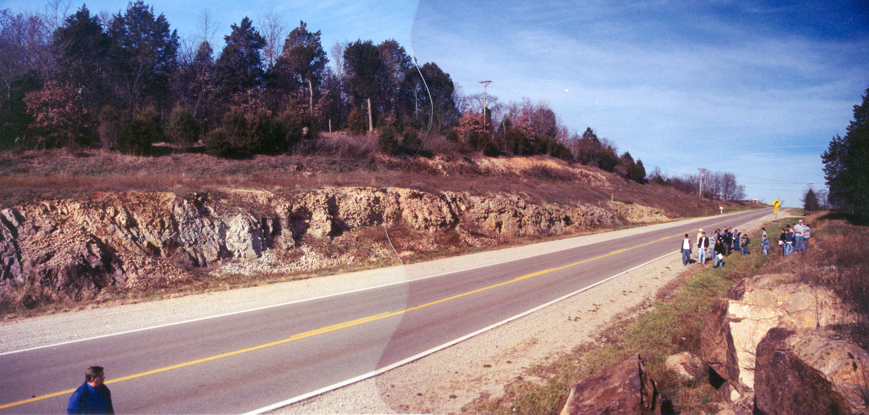
Figure 4. Right to left: Lamotte Sandstone lapping onto Precambrian age tuff, and then rhyolite. Cut on west side of Hwy 21.
As we proceed down Hwy 21 we start to catch a glimpse of the St. Francis Mountains. We begin enjoying an unhindered view of a more open terrain with grand vistas, stretching across miles around us. These bedrock knobs are composed of Precambrian igneous rocks over a billion years old. The summits rise 300 to 900 feet above the surrounding terrain, or lowlands, upon which we are traveling. The highest point in Missouri is Taum Sauk Mountain, south of Ironton, which reaches an elevation of 1772 feet.

Stop Number 3 - Missouri Red Granite Co. Graniteville Quarry ( 22.9 miles south of junction Hwys 8 and 19 in Potosi).

This quarry is the major supplier of Missouri Red Granite dimension stone, used to great extent in St. Louis and elsewhere in the Midwest. The granite has been quarried at this location since 1869. It is operated by Missouri Red Granite Company. This is a distinctive dimension stone because of its color, high quality, and recognized durability. It has been used for curbs in St. Louis, as well as the stone for Union Station and many other buildings downtown. The red granite was also used in constructing the governor’s mansion in Jeff City, the sun dial pedestal in front of Norwood Hall, and the Millennium figures in front of Castleman Hall on the Missouri S&T campus. Figure 6 shows a typical quarry production block of this product as it might be prepared for finishing. At this stop, we will tour the quarry with the facility manager, Mr. Bill Francis. Observe the methods used to loosen the rock and why these methods are used. Notice the size of bocks produced and the various uses for these products. Ask tour guide about “burners” and how these are used to cut the blocks.

Stop Number 4 - Elephant Rocks State Park. Eat Lunch and Tour Park – Total time is 40 minutes.

Elephant Rocks State Park is an excellent example of state ownership of a unique natural feature. The granite of these rocks cooled slowly at great depth in the earth’s crust, about 1.2 billion years ago. We can deduce this from the large, well-developed crystals of mica, quartz, and feldspar. Subsequent to this cooling and solidification, this rock was uplifted and fractured – likely along fractures that formed from the contraction of the rock mass as it cooled. The granite is regularly fractured by semi-parallel suites of regional systematic joints, roughly orthogonal to each other. These joints form the basic “building blocks” of the features we’ll examine.
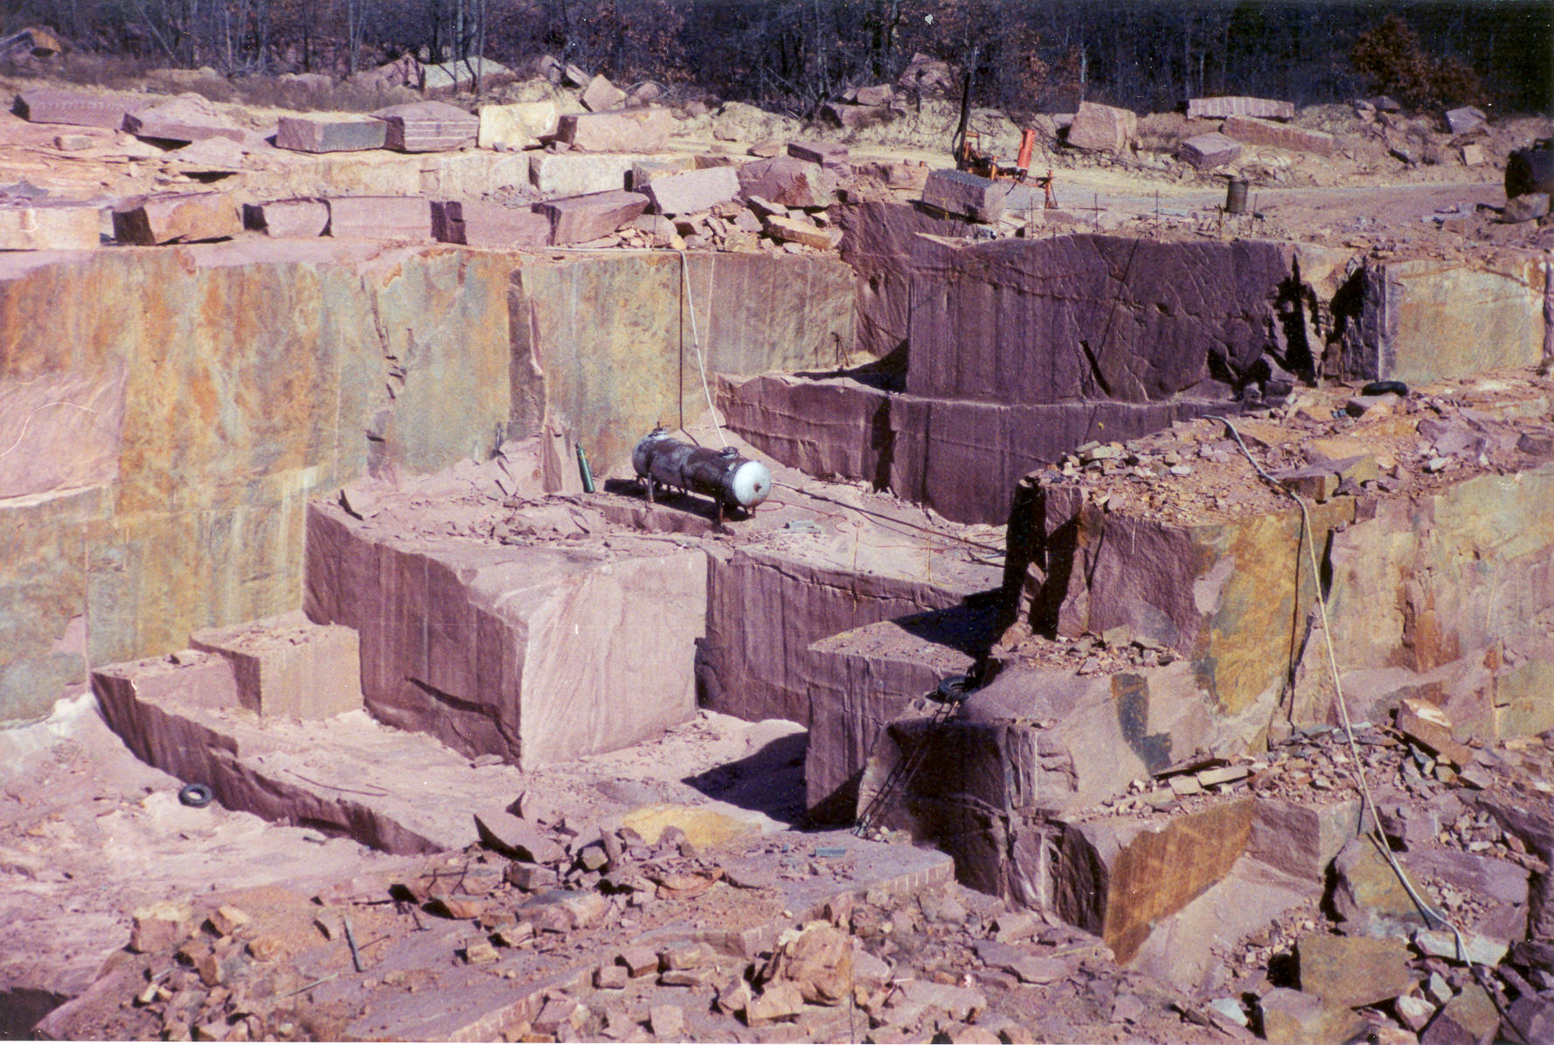
Figure 6. Production Blocks in main pit of Missouri Red Granite. Note burner tank.
Exfoliation is a weathering process that serves to rounded these blocks off, through the formation of tensile extension fractures that are typically curvilinear. When the rock breaks along these curved lines, it alleviates stress concentrations that occur at the rectangular intersections of these blocks. Exfoliation can be triggered by release of stored elastic strain energy, cased by unloading (release of residual stresses), rapid excavation, thermal expansion/contraction, chemical weathering (hydration of micas), or mechanical weathering (ice wedging, root action, or fire). Make special note of the pothole structures up on top of the ridgeline. The “natural bird baths” were formed as rain water accumulated in slight depressions and initiated freeze-thaw weathering action, as well as hydration of micas and feldspars. Enjoy a walk around the pathway that leads to a number of elephant size blocks, both young and old, and find a place to eat your sack lunch. Be sure to carry your refuse out to the trailhead and dispose of it properly.

Stop Number 5- Iron Mtn Trap Rock Quarry (On Hwy N; 4 miles north of Intersection of Hwys 21 and N).

This quarry, Iron Mountain Trap Rock Company, is a supplier of the construction material called “trap rock.” The term “trap rock” has its origins in Sweden, where the word “trapa” is used to describe “stair like”. Swedish miners used this term to describe the rectangular benches formed by intersecting orthogonal joints. In the United States the term trap rock is often used to describe a crushed rock product derived from the working of any hard crystalline rock that exhibits regular orthogonal jointing. The pre-Cambrian rhyolite of Missouri generally fits this description. They produce high durability railroad ballast, shipping four 60-car unit trains per day. Another of their products (minus 3/8 inch) is used as a “topping” agent for the upper three inches of concrete slabs in warehouse stores that routinely employ forklifts, increasing surface durability and safety. Why would a slight divot in the floor slab affect the stability of a small forklift?
Mr. Mike White will lead us on a tour of this site to see the crushing and screening plant where the “shot” rock is crushed and classified for various market uses. This site was previously famous for the extraction of iron ore. Between 1837-89 a mountain 300 feet high was completely excavated from this area, along the St. Louis, Iron Mountain and Southern Railway, built before the Civil War. Those operations extended an open pit to a depth of 100 feet below ground. The old mine headworks and water towers date from underground mining of iron ore carried out here by the M.A. Hanna Mining Co., between 1937-65.
You should learn about the general means of crushing and screening to make construction materials of properties that you will specify to meet design needs for your projects. Ask about different gradations for railroad ballast rock. We will also visit the active quarry pit where the rock is loosened and haled to primary and secondary crushers, and view their screening plant. Overburden removal, drilling and blasting, and ore selection (based on specific gravity) will be observed at the quarry pit area.

Stop Number 6 - Fort Davidson State Historic Site in Pilot Knob –
(3 miles south of Hwy 21/N intersection)

This is the site of one of the largest Civil War battles in Missouri. It preserves and interprets the ruins of Fort Davidson, an earthen redoubt constructed by Union forces to protect the St. Louis and Iron Mountain Railroad and the area’s iron mining resources in 1863. In addition, the site also preserves and interprets what remains of the cultural landscape associated with the Battle of Pilot Knob in September 1864. Depending on available time, we will take a brief tour of the fort and the adjoining museum and learn something about one of the most successful and bizarre retreats in military history (see summary write-up, after Stouts Creek Shut-In)

Optional Stop Number 7 – Stouts Creek Shut-In (2.3 miles east of Arcadia, along Hwy 72). Cross the highway only after our traffic warning cones have been set and the two traffic control officers are in place to protect us from passing traffic. Very carefully look at this outcrop and land form. Only cross the road from and to the bus ONLY AFTER HAVING CAREFULLY CHECKED FOR APPROACHING TRAFFIC FROM BOTH EAST AND WEST.

Our travels take us to this Ozarks feature that has been formed as a direct function of the geologic conditions at the site. The term “shut-in” was brought to the Ozarks by early settlers from the Southern Appalachians. It refers to the sudden narrowing of a bedrock canyon, which widens again downstream of the construction. This is Stouts Creek Shut-In and it is formed by the more resistant rhyolite porphyry underlying this portion of the valley. The Greek root of the word porphyry means “purple,” which is the color of the higher density rhyolite. Figure 7 shows a panoramic view of the shut-in looking down stream through the feature. The steepness of the stable slope in the resistant rock is noticeable in the left, north wall of the valley. Notice the characteristic “V” shape of this stream-cut valley.
The term “shut-in” is a term that originated in the Ozarks and refers to the “shutting in” of a valley as the valleys walls pinch the channel. Notice the almost complete absence of channel gravels and sands in the shut in, beneath the highway bridge. Johnson’s Shut-Ins State Park, southwest of Ironton, is a well-known recreation area that is similar to Stouts Creek Shut-In, but much larger because of a greater tributary watershed area. However, Stouts Creek Shut-In is an excellent example of this land form and shows a “text book” example of the influence of resistant rock on the development of the drainage way.
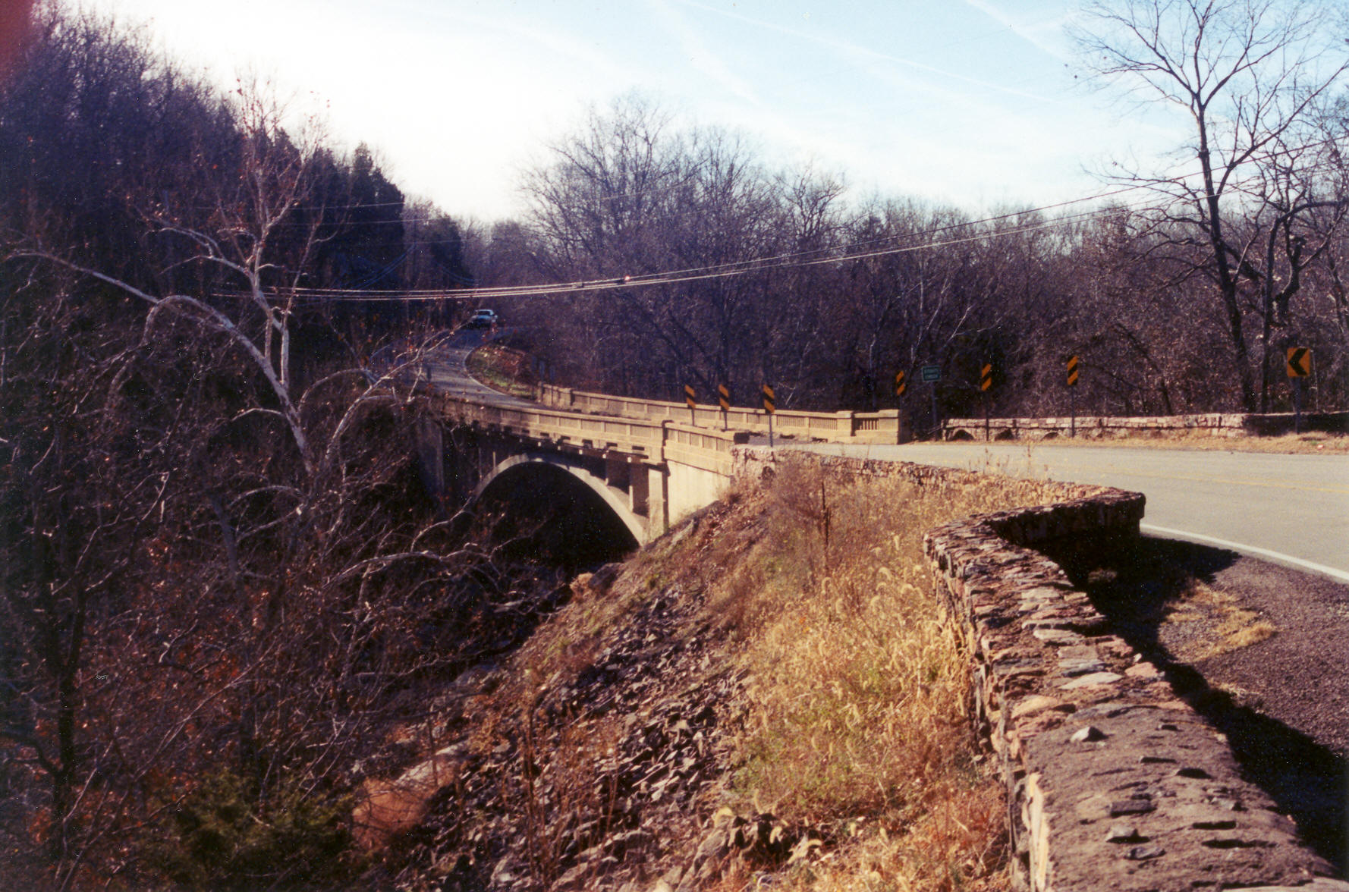
Figure 7. Stouts Creek Shut-In. View looking downstream, through the feature.

The Battle of Pilot Knob – September 27, 1864 The Civil War battle that sealed the fate of the Confederacy west of the Mississippi River.

In September 1864 Confederate General Sterling Price, a former governor of Missouri, led a force of almost 13,000 men in an attack on Missouri. His army set out from the Confederacy’s largest base west of the Mississippi, near Camden, in southwestern Arkansas. The Confederate force was split into three columns roughly 20 miles apart, foraging all of their provisions from the lands they crossed. They entered Missouri through Doniphan, thence onto Paterson, before stopping in Fredericktown and Farmington. Their intended target was St. Louis, the largest city west of the Mississippi River and believed to be lightly defended by State Militia. Smaller Union garrisons in Missouri were located at Pilot Knob, Rolla, Springfield, and Jefferson City. When Price’s forces reached Fredericktown his presence was well known to the Union Commander of the Department of Missouri based in St. Louis, General William S. Rosecrans. Price received reports from Confederate spies in St. Louis that the Federal garrison there had been reinforced by as many as 20,000 regular troops recently brought upriver from Memphis. In actuality, these reinforcements numbered only 4,500 men, taken from the Union Army’s 16th Corps.

Worried at these reports, on September 25th Price changed his plans and decided to strike west, through the Union garrison at nearby Pilot Knob and onto the State Capitol at Jefferson City. He hoped to capture arms, ammunition and gunpowder for about 1500 troops accompanying his columns that were without arms. He sent his cavalry under General Joseph Shelby to sever the supporting railroad lines connecting St. Louis to Pilot Knob, Rolla and Jeff City, ahead of his ground forces. In the fall of 1864 Pilot Knob was a small iron mining town of just 200 people and the terminus of the St. Louis, Iron Mountain and Southern Railway from St. Louis (Rolla maintained a similar fort at the terminus of the St. Louis and San Francisco Railroad). The Union earthworks at Pilot Knob were named Fort Davidson (see plan view, below). It was situated in the valley, surrounded by peaks rising 500 to 600 feet and covered by scrub oaks and undergrowth. Price ordered Confederate Major General James Fagen’s Division of some 2,000 men to proceed west from Fredericktown, along Stout’s Creek, towards the Arcadia Valley, thence northward through Ironton, to Fort Davidson. This route leading to the fort from the south was unprotected, the fort only protecting the northern pass to the Arcadia Valley. Other Confederate forces approached Fort Davidson from the north and east, via Farmington. The summits of Pilot Knob and Shepherd’s Mountain were about 1,200 yards from the Union fort, easily within range of the fort’s artillery: four heavy siege canons with 32 pound shells, three howitzers with 24-lb shells, three 12 inch mortars and six mobile 6-lb field canons. The fort was of earthen construction, supporting rifle parapets 9 feet high and surrounded by a dry moat, ten feet wide and 7 feet deep. The parapets had a clear field of fire extending out 900 yards in every direction. It had been the Federal’s original intention to construct ancillary outposts with Union artillery on Pilot Knob and Shepherd Mountain, to protect the fort from being shelled by enemy artillery spotted on the heights, but this hadn’t been accomplished. The Union forces defending Fort Davidson were all Missouri State militia and cavalry units, none of whom had any combat experience.

On Monday September 26, 1864 around 10 AM Union Brigadier General Thomas Ewing arrived at Fort Davidson on the last train from St Louis to take command. He accompanied 200 combat-tested regular troops of the 14th Iowa Regiment. This brought his total garrison strength to 886 men. Ewing was hastily dispatched by General Rosecrans to oversee the defense of Fort Davidson because the Rebel Army was known to be close by, likely heading for St. Louis. Rosecrans had instructed Ewing to evacuate the fort if he found himself faced by Price’s entire army, believed to number more than 12,000.

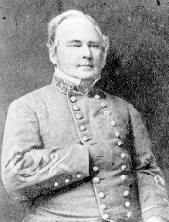 | 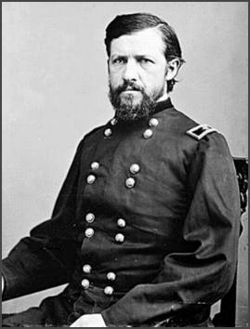
The opposing force commanders: Confederate General Sterling Price (left) had 13,000 soldiers and cavalry under his command (about 1500 of which were unarmed). Brigadier General Thomas Ewing (right) was surrounded and hopelessly out-numbered, with a total force of 886 men. Ewing’s tenacity, imagination, and miraculous escape have been studied by military tacticians world-wide since the Civil War.

At the very moment Ewing arrived and began assessing his new assignment 9,000 Confederate troops were closing in on him from the east. He was unaware that Confederate General Joseph O. Shelby’s cavalry had already cut off the Ironton Railroad, eliminating his planned path of retreat, back to St. Louis. On the afternoon of the 26th Ewing took the precaution of sending two companies of the newly arrived 14th Iowa Regiment southward to reconnoiter the “shut-ins” bounding routes leading into the Arcadia Valley. One of these companies immediately encountered the lead elements of General Fagan’s division at Stouts Creek Shut-In, about 2.3 miles east of Arcadia. The 50 or so Union troops were quickly overwhelmed by the 2000 soldiers of Fagan’s Division and driven back to Ironton, where bullet holes still mark the courthouse. On hearing the firing to his south, General Ewing ordered two more companies of the 14th Iowa along with two 6-pound canon and all his cavalry down to Ironton to reinforce the companies fighting there. To everyone’s amazement the ragged Arkansas troops of Fagan’s lead brigades were cut down by accurate and sustained fire from the veteran Iowa soldiers, and were forced to retreat and take refuge at the Shut-Ins on the evening of September 26th.

That evening Fagan’s Division was reinforced by the Major General John Marmaduke’s Division of 3,000 additional Confederate soldiers. As these events were unfolding General Ewing was also informed that the Ironton Railroad had been severed by Confederate forces and he knew he was surrounded and cut off from reinforcements. Ewing ordered his troops to construct gun platforms for his four remaining 6-lb canon, hoping these would provide additional cover fire facing the main attacking force, coming from Ironton.

At dawn on Tuesday September 27th the combined Confederate forces hurled themselves at the Union troops holding up in Ironton, quickly forcing them northward, back towards Fort Davidson. Their on-scene commander, Major Wilson (who had commanded the fort prior to Ewing’s arrival), was taken prisoner. By noon the retreating Union forces were consolidated at Fort Davidson, with 400 men inside the fort and the remaining 300 placed dug rifle pits that had been excavated by African American companies the previous afternoon, outside the fort. The pursuing Confederate forces began to swarm the heights of Pilot Knob and Shepherds Mountain. Then, the Union forces noted Confederate cavalry approaching from the north and beginning to scale Cedar Mountain. At this juncture, General Ewing realized that he was likely facing the entire Confederate Army of 9,000 to 13,000 men, with a force of just 886 men. His chances of survival were slim.

With Fort Davidson surrounded the Confederate generals convened a war council in Ironton. They felt their plans were developing perfectly, even though Fagan’s lead division had suffered more than 200 casualties. The one stumbling block in their plans was the unexpected news that they were facing “veteran Union forces,” not the untested state militia units they expected. The veteran Iowa soldiers proved to be expert marksmen and maintained order in the face of overwhelming opposition. The Confederate generals decided to execute captured Union Major James Wilson, because of his role as an allegedly ruthless Confederate guerilla hunter in rural Missouri. During the first flag of truce the Confederates selected Lieutenant Colonel Lauchlan Maclean to Fort Davidson to demand its surrender. Maclean was a fiery Scotsman who loathed the Federal’s practice of employing former slaves as soldiers. He recognized Ewing and some of his African American soldiers. Ewing denied Maclean’s offer of surrender. Insolent about this seemingly brash refusal, Maclean returned to Price’s headquarters and informed everyone of Ewing’s presence and that of the Negro troops (the Confederacy exercised an official policy of executing white officers who volunteered to lead Negro troops). Ewing was a wanted man in the Confederacy because of his role in excising Southern sympathizers suspected of giving aid to Confederate guerilla William Clarke Quantrill, earlier in the War (described later). Ewing would have been executed if he had been captured.

While Colonel Maclean was soliciting the fort’s surrender, Confederates gunners were already beginning to position ten heavy siege canons on Pilot Knob and Shepherds Mountain, believing the lightly constructed fort could only withstand 15 minutes of shelling before it would be compelled to surrender. Pilot Knob, just east of the fort, was the easiest to set up artillery because it had a prominent notch in its summit from pre-War quarrying of the rhyolite porphyry. When the first Confederate canon was set up on Pilot Knob, the overconfident rebels opened fire on the fort, without waiting for the other nine guns to be positioned. Within minutes of this opening salvo the Union guns returned fire, destroying the Confederate gun and killing all 12 of its crew. This Confederate canon (on its restored carriage) is on display at the Visitor’s Center. This initial artillery exchange occurred around 1 PM.

At this juncture, Sterling Price changed his mind and ordered an all-out frontal assault on the fort, to commence at 2 PM. During the hour of quiet the Union gunners lowered their canon in preparation for firing deadly canister rounds across the grassy plains surrounding the fort. The Confederates formed up on the mountain slopes under cover of the oaks. Not all the Union soldiers could be fitted into the cramped confines of the fort so these men were kept behind the parapets to load rifles and pass them back and forth. Those who had previously qualified as sharpshooters or marksmen were placed on the parapets. The men lining the rifle pits dug out in front of the fort were instructed to retreat into the fort if their lines were breached by the Confederates. The Missouri volunteer cavalry brigade was sent mounted to the rear of the fort to hold the road leading northwest to Caledonia and Potosi. Each Union rifleman was issued 100 rounds. All thought it would be their last day alive, but were determined to sell their lives dearly.

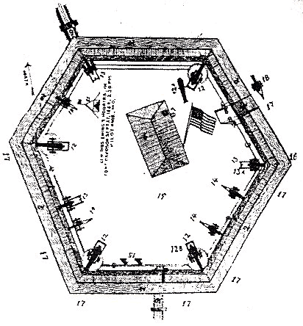 | 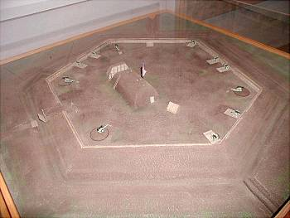
Map of the six-sided Union earthworks and canon comprising Fort Davidson near Pilot Knob (left). The right view shows a physical model of the fort on display at the site today.

At 2 PM the Confederate assault on Fort Davidson began, lead by Brigadier General William Cabell’s Brigade. Cabell was a Virginian, a West Point graduate and one of the designers of the Confederate Stars and Bars battle flag. With a screaming cheer 9,000 Confederate troops poured forth in a multi-pronged coordinated attack. The Confederates were formed in columns three ranks deep and began moving slowly toward Fort Davidson. Cabell’s Brigade occupied the Ironton Gap between Pilot Knob and Shepherd’s Mountain, where most of Fort Davidson’s large siege guns were trained. The Confederates had brought their remaining artillery up to cover the attack. Unfortunately for them, the fort’s earthen ramparts Davidson didn’t present a very prominent target, protruding a few feet above the valley floor.

Seeing the onslaught before him, Union General Ewing ordered his men to hold their fire and brought the two mobile canons back into the fort, to better control and concentrate his artillery fire. After a few minutes the 11 federal guns opened fire on the advancing southerners at a range of 800 yards. At a distance of 600 yards the rebel forces were ordered to quick step. At this juncture the 300 men positioned in the rifle pits retreated to the fort, scrambling across the dry moat because the ropes to the draw bridge had been shot out. When the rebels reached a distance of 500 yards Ewing gave the order to open fire. Some 300 rifles, all accurate Springfield and Enfields handled by expert marksmen, opened up, obliterating the lead elements of the Confederate onslaught. The next volley came a few seconds later because the supporting soldiers were reloading and passing their own rifles. Confederate survivors described the fire as “machine like,” rapid and continuous, not the 30 seconds or so between volleys that they were expecting. Despite their growing losses the Confederates troops marched on.

At 200 yards the Confederates fired their first volley, slicing the sandbag parapets of Fort Davidson. After firing the Confederates broke into a mad running charge punctuated by shrill Rebel yells. It seemed as though nothing could stop the screaming mass of men closing in on Fort Davidson’s earthen ramparts. Two of the Union canon exploded when their excited crews mistakenly double-shotted their barrels. Still, the Union gunners let go with everything they had in one last desperate effort to stem the tide of the Rebel onslaught. When just 30 yards short of the parapets the Confederate line wavered, broke and slowly fell back. Urged on by their mounted officers, they reformed, came again, but again, hesitated. A third time they were ordered to about-face and with General Cabell leading, a few managed to charge into the dry mount at the base of the parapet.

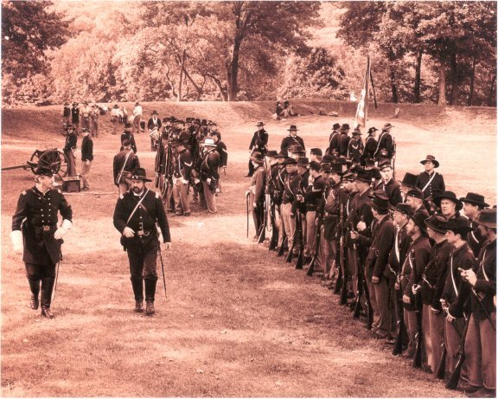
Photo of a recent Civil War reenactment within the confines of Fort Davidson.

There the fighting became desperate. Once into the dry moat the Confederates huddled and the Union riflemen leaned over the parapets and shot them down like rabbits. Small artillery shells were fused and thrown like grenades into the fort’s dry moat. The moat became the scene of incredible carnage, which demoralized the reinforcements, and the soldiers, no longer controllable, began to retreat. Ewing’s forces couldn’t believe their eyes. As they peered over the parapets the view was sobering. As long as the Confederates had been advancing it was impossible to judge their losses; as one man went down and other stepped into his place. Now as the Rebel forces streamed away from the Fort the Union soldiers were able to see the staggering losses suffered by the attacking force. For a distance of 500 yards on three sides of the fort the surrounding fields were covered with bodies. Each time the Rebels had broken ranks and retreated Union gunners had continued firing, hitting hundreds of the enemy in their backs. In just 20 minutes the Confederates had lost over 1,000 men.

A black rainy night enveloped Arcadia Valley that evening. The Confederate forces had taken a terrible licking and were in a state of recuperation. Overwhelmed by the number of wounded General Price instructed subordinates to approach the fort under a flag of truce in the morning to ask for medical assistance. Price also ordered all his remaining canon to be set up and entrenched on Shepherd Mountain, overlooking Fort Davidson. Runners were sent to the Confederate cavalry units at Potosi asking them to return and join in a renewed attack the following day. The Rebels also began constructing siege ladders to help scale the dry moat. Out in Fort Davidson only a single dim lantern was observed.

Late that same evening Union General Ewing held a council with his subordinates. He decided they should evacuate the fort. Their losses for the afternoon had been 75 men killed or wounded at the fort and about double that number missing from the hit-and-run attacks in the Arcadia Valley the previous two days. He assumed that General Price would not repeat the day’s frontal assault tactics and would chose instead to entrench his forces and artillery on the heights surrounding the fort, laying siege to it. Around midnight Ewing ordered his troops to muffle the wheels of their six mobile field canon and placed the veteran 14th Iowa troops in the van of soldiers who walked silently out of Fort Davidson, northward along the road leading northwest, to Caledonia. One of the great miracles of the Civil War then ensued: Ewing’s men moved up the road right through the loose Confederate lines and were never recognized or challenged in the darkness.

According to a preset plan, a squad of men left behind at the fort ignited the powder magazines at 2 AM. Curiously, the Confederates deduced that the explosion was accidental, never contemplating that a successful withdrawal could be made in the face of so many troops surrounding the fort. At dawn the Confederates arose to find Fort Davidson empty! At this juncture Sterling Price again let his emotions cloud his judgment. He sent General Marmaduke’s Division after Ewing. Ewing’s column had run headlong into General Shelby’s Confederate Cavalry at Caledonia and was engaged in a successful rear guard action. Ewing was forced to retreat westerly, even splitting his force for awhile, trying to reach the St Louis and San Francisco (Frisco) Railroad line that ran between Sat. Louis and Rolla. His forces adroitly employed their six artillery pieces to keep the pursuing cavalry at a distance. Marmaduke and Shelby spent the next three days chasing him, but were unable to circumvent their retreat. Ewing’s force reached the Frisco rail line near Leasburg, where they were greeted by the Union’s 17th Illinois Cavalry, who rushed up from Rolla, led by Colonel Beveridge.

The Confederate campaign into Missouri ended in dismal failure. The attack on Fort Davidson wasted a week of precious time, allowing Union regulars in St Louis to dig in along the Meramec River and entrench their artillery. The Union garrisons at Rolla (Forts Dette and Wyman), alerted to the Confederates by Ewing, moved their forces up to Jefferson City, to reinforce the garrison there, along with the remnants of Ewing’s force. There had been no victory for the Confederates, two of their three divisions having been chewed up badly. The Confederate forces straggled northward, through Franklin, Gasconade, and Osage Counties, looting everything in sight to sustain them. Upon reaching the now-fortified state capitol at Jefferson City, Sterling Price decided not to make a frontal assault on the fortifications. With Union forces now advancing on his rear and on his southern flank his army marched onto defeat at the Battle of Westport in Jackson County, and then began a long and laborious retreat down the Missouri-Kansas-Arkansas line all the way to east Texas. Of the 12,000 troops under his command, about 4,000 made their way back to Texas. Sterling Price, the Missouri governor who had begun the war with a startling victory at Wilson’s Creek near Springfield in 1861, ended the war in disgrace, taken before a Confederate Board of Inquiry to investigate his failure as a military commander. Sic transit gloria mundi.

Epilogue - What could make a man so bold that he would refuse to surrender, at all cost ?
In the years since the Civil War, Brigadier General Thomas Ewing’s courageous defense of Fort Davidson and the miraculous retreat of his beleaguered command over the 67 mile path to Leasburg, have been examined in detail in many postgraduate programs, such as the Army’s Command and General Staff College at Fort Leavenworth. There is no doubt that Ewing was a brave individual. He accepted General Rosecran’s orders to coordinate the defense of Fort Davidson or abandon it to the enemy, with an eye towards defending St. Louis at all costs. Ewing personally led the first cadre of 200 regular troops sent to Fort Davidson over the St. Louis, Iron Mtn & Southern Railway, just before that line was severed by Confederate cavalry. He assumed charge of a perilous situation, out-numbered by more than 14 to 1. His rational assessment of his own command’s strengths and weaknesses, and his decision to extract his forces using stealth and bold action testify to his military prowess, gained entirely through on-the-job training up to that point in the war. Ewing was also lauded for engineering a textbook rear-guard action for three days, while being pursued by vastly superior forces, who possessed much greater mobility than his own. Some of this boldness may have emanated from the fact that Ewing was a wanted man in the Confederacy (described below).
After being promoted to Brigadier General in March 1863 (for his leadership in the Battle of Prairie Grove) he was given command of the District of the Border, which comprised of Kansas and western Missouri. This was a most difficult assignment because tensions in this area between pro-slavery/southern sympathies and anti-slavery/northern sympathies had been vitriolic before the outbreak of the Civil War, when Ewing had served as Kansas first Attorney General. The tensions between Missouri (a slave state) and Kansas (admitted as a free state, in January 1861) boiled over again a few months later, when the Civil War erupted in April 1861. Confederate guerrilla ‘General’ William Clarke Quantrill led a partisan assemblage of bushwackers who targeted Jayhawkers (people with Union sympathies) in a series of bloody ambushes in western Missouri and eastern Kansas. When Federal troops began executing guerrillas (because they didn’t wear uniforms), Quantrill retaliated by executing the prisoners he captured, including Union soldiers in uniform. This conduct outraged the nation’s leaders because it was in violation of the Napoleonic rules of war, which both sides had swore to obey when hostilities commenced in 1861.
In August 1863 Quantrill’s Raiders swept into Lawrence, Kansas and rounded up all the men and boys over 12 years old they could find and executed 150 of them, right in front of their shocked families. This tragic event occurred within General Ewing’s jurisdiction and everyone in the North, as well as President Lincoln, expected to him to bring Quantrill and his despised band of guerrillas to a quick and proper justice. But, this proved impossible when so many of the area’s civilian population were sympathetic to Quantrill. Frustrated by the lack of cooperation, General Ewing issued what came to be known as the infamous General Order № 11; which commanded civilians with Southern sympathies living in four western Missouri counties be expelled, and if they did not leave voluntarily, to be forced from their homes (and livelihoods) by Union cavalry. The order was not actually carried out, but 13 men were arrested, tried, and executed for either resisting arrest or being uncooperative with Union demands. While this was part of an effort to suppress irregular operations in the troubled border region, it left a black mark on Ewing’s legacy, which haunted him the rest of his life. The Confederate States of America issued an order for General Ewing’s execution, should he ever be captured. In mid 1864 Ewing’s authority was expanded to embrace the District of St. Louis, under General Rosecrans. So, surrendering to the Confederates was not an option for Thomas Ewing; he was a marked man with a price on his head. Maybe that’s the sort of pressure that makes a man brave beyond reasonable expectations. Ewing’s leadership, cunning tactics, and coolness under fire have always been held out as the hallmarks of a great combat commander.
Thomas Ewing, Jr. was promoted to major general of volunteers in March 1865 for his services in the defense of Missouri and the western theater, but he resigned his commission shortly afterwards and returned to his civilian career as an attorney. Between 1865-70 he practiced law in Washington, D.C., turning down two cabinet appointments from President Andrew Johnson. He then moved back to his native Ohio, where he served two terms as an Ohio Representative in Congress in the late 1870s. After running unsuccessfully for Ohio Governor in 1880, he moved to New York City to practice law there, and he enjoyed considerable notoriety and success in that regard. He was killed by a New York streetcar while crossing an intersection in 1896.
Generalized Bedrock Stratigraphy for the Rolla Quadrangle, Phelps County and Southeast Missouri
(Taken from and based upon the work of T. R. Beveridge (1970 unpublished); his work based upon
Gleason and E. McCracken’s analysis of cuttings from the drilling of the Rolla City well number 3, located in the NE¼, SW¼, NE¼, Sec. 3, T 37N, R 8W, Rolla 7½ Quadrangle.)
Depth to top (feet) | Formation and Thickness (feet) | Description
 | Jefferson City, 150+ | (Overlain by Cotter and locally by undivided Pennsylvanian fine grained sediments.) Thin to medium bedded, sandy, silty, cherty dolomite. Quarry Ledge 30 feet from base crops out at U.M.R. mine and near old Holiday Inn site, west of Rolla.
150 | Roubidoux, 150 | Cherty dolomite with two or three major sandstone beds. Prominent outcrops on I-44 west of Rolla. Originally supported pine forests. Forms topographic break with gentler slopes at top of steep bluffs along large streams. Sandstone is quarried for building stone in the St. James area.
255 | Gasconade, 315 | Thick-bedded to massive crystalline dolomite. Forms steep bluffs along Gasconade, Big Piney, and Little Piney Rivers. Major caves and springs. Base not exposed in Phelps and Pulaski counties.
535 | Gunter Sandstone, 35 | (Not exposed in Rolla area) Good aquifer, sandstone quarries in Lake of Ozarks area.
570 |  | Top of the Cambrian System rocks
 | Eminence, 260 | Thick-bedded dolomite, steep bluffs. Major caves and springs in southern Ozarks. Current, Jacks Forks, etc., rivers are fed by these springs.
830 | Potosi, 295 | Thick-bedded dolomite with much quartz druse. Barite deposits on weathered Potosi. Excellent aquifer.
1125 | Derby-Doerun, 100 | Medium-bedded dolomite. Prominent in Old Lead Belt, tends to act as a barrier to vertical movement of groundwater.
1225 | Davis, 175 | Limestone, dolomite, and shale. Prominent in the Old Lead Belt area and acts as a barrier to vertical movement of groundwater.
1400 | Bonneterre, 250 | Dolomite and limestone. Major lead bearing horizon of southeast Missouri, prominent in the Old Lead Belt.
1650 | Lamotte | Sandstone and arkose. Good aquifer. Common on the edge of the Precambrian outcrops in southeast Missouri.
1745 |  | TOTAL DEPTH of well number 3
1950 |  | Estimated top of the Precambrian rock

GE 50 Field Trip Reconnaissance Report Name ___________________________

1. Observation Site No. 1: Describe surface erosion observed emanating from the Lowes hardware site on the north side of I-44 in Rolla. _____________________________________________________________________________________________

2. Observation Site No. 2: Why does the plateau Cuba is built on begin dropping as we proceed south? _____________________________________________________________________________________________

3. Observation Site No. 3: Can you discern contact between weathered soils and underlying bedrock in these deep cuts slopes? Why not?
_____________________________________________________________________________________________

4. Observation Site No. 4: What kind of erosion do you notice in the stepped cuts made in the dissected carbonate upland along the southern side of the Meramec River valley?
_____________________________________________________________________________________________

5. Observation Site No. 5: Is the flood plain adjacent to Huzzah Creek flat and level like that of the Meramec River? Why not?
_____________________________________________________________________________________________

6. Stop No. 1: What is the “edgewise conglomerate” bed and what does “cryptoexplosive origin” connote?
_____________________________________________________________________________________________

_____________________________________________________________________________________________

7. Stop No. 2: Notice the variations in jointing, block size, and block geometry in the exposures in this highway cut. Do you see any joint suites which are adversely dipping with respect to the cuts? What mitigation measures could be undertaken to ensure traffic safety?
_____________________________________________________________________________________________
_____________________________________________________________________________________________

8. Stop No. 3: What are sheet joints? How does the quarry split the blocks of granite? What is most of their rock used for commercially?

_____________________________________________________________________________________________

_____________________________________________________________________________________________

_____________________________________________________________________________________________

9. Stop No. 4: What is exfoliation? How does exfoliation cause rounding of the granitic blocks ? _____________________________________________________________________________________________
_____________________________________________________________________________________________

10. Stop No. 5: What is “trap rock”? What is it used for? What sizes material do they export from this mine? How is their product shipped from this location?
_____________________________________________________________________________________________

_____________________________________________________________________________________________

_____________________________________________________________________________________________

11. Stop No. 6: What kind of rock is exposed on the crests of Shepherd’s Mountain and Pilot Knob?

_____________________________________________________________________________________________

